TAB 2 CARDIAC GUIDELINES

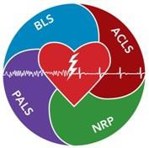

TAB 2 GUIDELINE 1
Consider ALS Backup
Universal Patient Care
LEGEND
EMR
EMT
A-EMT
EMT-P
MC Order

Aspirin 324 mg PO
(Unless documented Aspirin allergy)

CHEST PAIN | ACUTE CORONARY SYNDROME

HISTORY  - Age  - Medications (Viagra, Levitra, Cialis)  - MI, Angina, Diabetes, Post Menopausal  - Allergies  - Recent physical exertion  - Onset  - Palliation / Provocation  - Quality  - Region / Radiation / Referred  - Severity (1-10)  - Time (duration / repetition) | SIGNS / SYMPTOMS  - CP (pain, pressure, aching, vice-like tightness)  - Location (substernal, epigastric, arm, jaw,  neck, shoulder)  - Radiation of pain  - Pale, diaphoresis  - Shortness of Breath  - Nausea, vomiting, dizziness  - Atypical presentations  - Anginal equivalents | DIFFERENTIAL  - Trauma vs. Medical  - Angina vs. Myocardial Infarction  - Pericarditis  - Pulmonary embolism  - Asthma / COPD  - Pneumothorax  - Aortic dissection or aneurysm  - GE reflux or Hiatal hernia  - Esophageal spasm  - Chest wall injury or pain  - Pleural pain  - Overdose (Cocaine)

Cardiac Monitor / 12-Lead ECG
Perform procedure if able to transmit, do not
delay care to obtain EKG

Contact Medical Control

Nitroglycerin
0.4 mg SL q 5 min (SL max 3 doses)
Patient must have a SBP > 140 mmHg before each dose of medication is given (avoid if taking Viagra, Cialis, Levitra)
SBP drops below 90 mmHg

Transport to appropriate facility

If notified by receiving hospital after EKG transmission, divert patient to a designated STEMI Facility
Consider
ResQGARD

SPECIAL CONSIDERATIONS:

- Patients with 12-Lead ECG signs indicative of ST-segment elevation myocardial infarction (STEMI) will be triaged to the closest available PCI (Percutaneous Coronary Intervention) facility for treatment.

STEMI Criteria
  - ST-segment elevation, measured at the J-point, of 1mm or more.
  - ST-segment elevation must be present in two anatomically contiguous leads.
  - Probable new-onset BBB.
- Transmit 12-Lead ECG to the assigned receiving PCI facility as time permits. Notify On-Line Medical Control, during patient assessment transmission, that 12-Lead ECG has been sent.

Avoid the administration of NTG if the patient has taken Sildenafil (Viagra) or Vardenafil (Levitra) in the prior 24 hours or Tadalafil (Cialis) in the prior 48 hours.
- Avoid administration of supplemental oxygen (> 2 L / min) unless oxygen saturation < 94%

TAB 2 GUIDELINE 2
Consider ALS Backup
Universal Patient Care
CPAP
(Initial PEEP setting of 10 cm H₂O)
CONGESTIVE HEART FAILURE | ACUTE PULMONARY EDEMA

HISTORY  - Congestive heart failure  - Past medical history  - Medications (Digoxin, Lasix)  - Viagra, Levitra, Cialis  - Cardiac history - past myocardical infarction | SIGNS / SYMPTOMS  - Respiratory distress, Bilateral rales  - Apprehension  - Orthopnea / Paroxysmal Nocturnal  Dyspnea  - Jugular vein distention  - Pink, frothy sputum  - Peripheral edema, diaphoresis  - Hypotension, shock  - Chest pain  - Diaphoresis | DIFFERENTIAL  - Myocardial infarction  - Congestive heart failure  - Asthma / COPD / Pneumonia  - Anaphylaxis  - Aspiration  - Pleural effusion  - Pulmonary embolus  - Pericardial tamponade  - Toxic exposure

LEGEND
EMR
EMT
A-EMT
EMT-P
MC Order

Cardiac Monitor / 12-Lead ECG
Perform procedure if able to transmit, do not delay care to obtain EKG

Contact Medical Control
Transport to appropriate facility

SPECIAL CONSIDERATIONS:

- Immediately begin administration of oxygen and titrate for SpO₂ > 92%. This will maximize oxygen concentration and fully saturate circulating hemoglobin.
- If a patient is in extreme distress, it may be appropriate to proceed to assistance with Bag Valve Ventilation.
- For patients who have moderate to severe pulmonary edema, noninvasive ventilations should be started (CPAP). CPAP provides positive airway pressure and reduces the work of breathing. Preload and afterload are also both reduced by CPAP, which is very beneficial in CHF patients.

TAB 2 GUIDELINE 3 CARDIOGENIC SHOCK
Consider ALS Backup
Universal Patient Care
LEGEND
EMR
EMT
A-EMT
EMT-P
MC Order

Airway Managem ent
Monitor lung sounds for fluid overload

HISTORY  - Age  - Medications  - Past medical history (MI, Angina, Diabetes)  - Allergies  - Recent events  - Onset | SIGNS / SYMPTOMS  - Chest pain  - Systolic BP < 100 mmHg  - Rales or crackles ("wet" lung sounds)  - Pedal edema  - Dyspnea  - Diaphoresis  - Nausea / Vomiting | DIFFERENTIAL  - Trauma vs. Medical  - Myocardial infarction  - Pulmonary embolism  - Pneumothorax  - Chest wall injury or pain  - Sepsis

Cardiac Monitor / 12-Lead ECG
Perform procedure if able to transmit, do not delay care to obtain EKG

Contact Medical Control
Transport to appropriate facility

TAB 2 GUIDELINE 4
Contact Medical Control
CARDIAC ARREST – ADULT | PEDIATRIC

HISTORY  - Time of onset, time lapse until CPR  initiated  - Events leading to arrest  - Estimated down time  - Past medical history  - Medications  - Existence of terminal illness  - DNR | SIGNS / SYMPTOMS  - Unresponsive  - Apneic  - Pulseless  - Signs of lividity, rigor mortis  - Evidence of drug ingestion  - Trauma  - Hypothermia | DIFFERENTIAL  - Medical vs. Trauma  - Ventricular Fibrillation vs. Pulseless  Ventricular Tachycardia  - Asystole  - Pulseless Electrical Activity (PEA)
Universal Patient Care
Consider ALS Backup

YES

NO
Begin Continuous Chest Compressions at 100 / min (turn on metronome)
Dead On Arrival (DOA) Guidelines
Automated CPR Device
(When Available)
Withhold Resuscitation
LEGEND
EMR
EMT
A-EMT
EMT-P
MC Order

Return of Spontaneous
Circulation (ROSC)
Criteria for Termination
of Resuscitation
Interrupt compressions only as per
Defibrillation Procedure

Ventilate no more than
8 – 10 breaths / minute
Airway Managem ent
Ventilations 8 – 10 / min
Automated Defibrillation Procedure
Attach AED
Continue Resuscitation
Transport to appropriate facility
Stop Resuscitation

SPECIAL CONSIDERATIONS:
- Resuscitation is based on proper planning and organized execution. Procedures require space and patient access. Make room to work. Utilize Team Focused Approach (PIT Crew CPR) assigning responders to predetermined tasks.
- Unless patient / crew is in an unsafe environment all resuscitative measures should be performed where the cardiac arrest occurred. Sustained ventricular tachycardia / fibrillation greater than 20 minutes should be discussed with online medical control for potential transport.
- Efforts should be directed at high quality and continuous compressions with limited interruptions and early defibrillation when indicated.
- MCMA acronym for Cardiac Arrest Priorities
  - Metronome – Rate above 100 beats per minute but allow adequate recoil
  - Compression – harder, deeper, faster (continuous with advanced airway in place)

INTERRUPTION IN COMPRESSIONS NEEDS TO BE KEPT TO A MINIMUM.
    - “Push Hard and Push Fast” at a rate of 100 – 120 beats per minute
      - Allow chest to recoil from compressions
      - Limit interruptions to chest compressions

If no advanced airway (BIAD, ETT) compressions to ventilations are 30:2. If advanced airway in place ventilate 10 breaths / minute with continuous, uninterrupted compressions.
    - Deploy and utilize resqCPR system or automated CPR device when appropriate and available.
      - With the efficacy of automated CPR devices, compressions should not be stopped during defibrillation
  - Monitor – defibrillate after 2 minutes of CPR if down > 4 minutes
    - AED should be used on all children over the age of 1 year
    - AED should deliver one (1) shock and then CPR should immediately begin
  - Airway

DO NOT HYPERVENTILATE
    - Breathing / Airway management after second shock and / or 2 rounds of compressions (2 minutes each round.)

    - DO NOT STOP CPR TO INTUBATE EARLY IN THE ARREST. Initiate basic airway (King LT or LMA preferred) with Bag Valve Mask ventilations and apply ResQPOD device inline or with constant mask seal, ventilate at a rate of 10 breaths / minute with oxygen source at flow rate of 15 LPM.
    - Utilize EZ cap or capnography device if available, evaluate CPR (EtCO₂ > 10 mmHg).
      - In patients with return of spontaneous circulation (ROSC), the first visualized sign may be a significant increase in capnographic waveform and capnogram value. C0₂ washout through the lungs upon return of mechanical circulation proves a valuable sign of ROSC and should prompt the EMS providers in the field to assess patient circulation (pulses).
      - Rescue breaths over one (1) second
      - Limit ventilations one (1) every six (6) seconds or ten (10) per minute
      - Limit tidal volumes to 500 ml for adults if using oxygen
    - Upon placing and evaluating an advanced airway (ET, LMA, KING), it is strongly recommended that the patient’s head be immobilized with a C-collar and/or CID to maintain airway control.
- Maternal Arrest - Treat mother per appropriate guideline with immediate notification to Medical Control and rapid transport as per Cardiac Arrest Destination Plan. Place mother supine and perform Manual Left Uterine Displacement moving uterus to the patient’s left side. AED use is safe.
- If any underlying cause of arrest is suspected (i.e., hypothermia, diabetes, overdose), it would be appropriate to integrate those treatment guidelines during the resuscitative process. Do not, however, delay administration of cardiac medications while integrating treatments from other guidelines.
  - The most common cause of pediatric cardiac arrest is HYPOXIA for this reason our primary responsibilities differ somewhat from that of an adult. If intervention is swift and effective, the child can often be restored to full health. This makes the psychological burden and reward for you as providers all the greater.

COMPONENT | ADULT | CHILD | INFANT
Recognition | Unresponsive (for all ages)
 | No breathing, not breathing normal (gasping) | Not breathing or only gasping
ACTIVATE | Activate when victim found unresponsive. | Activate after performing 5 cycles of CPR.
Emergency response |  | For sudden, witness collapse, activate after verifying that victim unresponsive
 | HCP: if respiratory arrest likely, call after 5 cycles (2 minutes of CPR)
CPR Sequence | CAB | CAB | CAB
CIRCULATION | Carotid |  | Brachial or femoral
HCP: Pulse check (< 10 sec) | (HCP can use femoral in child)
Compression landmarks | Center of chest, between nipples |  | Just below nipple line
Compression method | 2 hands: Heel of 1 hand, other hand on top | 2 Hands: Heel of 1 hand with second on top or | 1 rescuer: 2 fingers
 |  |  | HCP: 2 rescuers: 2 thumb- encircling hands
 |  | 1 Hand: Heel of 1 hand only
Compression depth | At least 2 inches | At least 1/3 AP diameter of the chest
Compression rate | Approximately 100 – 120 beats / minute (push hard, fast, allow full chest recoil)
Compression - ventilation ratio | 30 to 2 | 30 to 2 (single rescuer)
 | (1 or 2 rescuers) | HCP: 15 to 2 (2 rescuers)
(5 cycle / 2 minutes) | (1 cycle should take 18 - 23 seconds)
AIRWAY | Head tilt-Chin Lift (HCP: suspected trauma, use jaw trust)
BREATHS
Initial | 2 breaths at 1 second / breath | 2 effect breaths at 1 second / breath
HCP: Rescue breathing without chest compressions | 10 to 12 breaths / minute  (approximately 1 breath  every 5 to 6 seconds) | 12 to 20 breaths / minute
 |  | (approximately 1 breath every 3 to 5 seconds)
HCP: Recue breaths for CPR with advanced airway | 10 breaths / minute (approximately 1 breath every 6 to 8 seconds)
DEFIBRILLATION
AED | USE adult pads. Do not sue child pads / child system. | HCP: Use AED as soon as available for sudden collapse and in-hospital | No recommendation for infants < 1 year of age.
 | HCP: For out-of-hospital response may provide 5 cycles / 2 minutes of CPR before shock. If response > 4 to 5 minutes and arrest not witnessed. | All: After 5 cycles of CPR (out-of-hospital). Use child pads / child system for child 1 to 8 years if available. If child pads / system not available, use adult AED and pads.

TAB 2 GUIDELINE 5
CARDIAC ARREST – “PIT CREW” CPR GUIDELINE
- Clinical Indications
  - Patient in cardiac arrest
- Contraindications
  - < 1 year or patient size prohibits access
- Procedure
  - Establish prior to arriving at patient’s side, the following responsibilities:
  - Position 1

ALWAYS on patient’s right side
    - Assesses responsiveness/pulses
    - Initiates chest compressions immediately if needed
    - Alternates chest compressions w/ Position 2
    - May operate BVM when not performing chest compressions
    - Assembles, applies & operates automated CPR device when available
  - Position 2

ALWAYS on patient’s left side
    - Applies AED pads immediately
    - Operates AED after each 2-minute cycle of compressions
    - Alternates chest compressions w/ Position 1
    - May operate BVM when not performing chest compressions
    - May assist with inserting / securing King Airway
  - Position 3

ALWAYS at patient’s head
    - Assembles and appropriately applies all equipment for airway and ventilations
    - Opens/clears airway, Suction as needed
    - Assembles King Airway
    - Inserts & secures King Airway
    - Ventilate at appropriate intervals w/ BVM
    - Alternates w/ Positions 1 & 2 for chest compressions as needed
    - Operates BVM when not performing chest compressions
  - Position 4

ALWAYS outside of CPR “Triangle”

    - Functions as a “Team Leader”, assesses quality of compressions/ventilations
    - Assembles O2, BVM, ResQPod and Thomas Tube Holder (or alternative means of securing King airway)
    - Turns on audible metronome (if available) and/or timing lights on ResQPod
    - Gathers patient information (may delegate to Police Officer if available)
- SPECIAL CONSIDERATIONS:

Minimally interrupted compressions at a rate of 100 BPM.
  - Appropriate depth and quality of compressions.
  - Consider compressor fatigue and change compressors as needed. Change at the minimum every (2) minutes.
  - Team approach.
    - Infants and small children may require modification of the procedure due to size
    - This procedure is based on a 4-person crew of providers
    - If there is only a 3-person crew, Position 3 will incorporate Position 4 responsibilities
    - If only a 2-person crew, follow standard CPR Guideline

“Pit Crew” CPR Positions
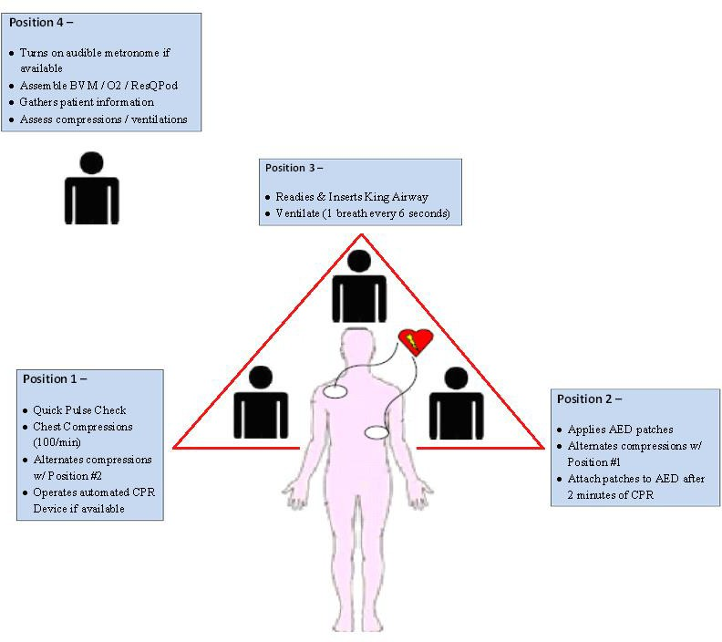

TAB 2 GUIDELINE 6 CARDIAC ARREST – HYPOTHERMIC
Treat for Hypothermia
edical Control

Stop Resuscitation
Transport to appropriate facility

Severe Hypothermia (< 30ºC)
Start CPR Attempt defibrillation (x 1)
- Avoid rough movement
- Remove patient from cold
environment
- Remove wet clothing
- Protect against heat loss
- Cover with blankets
Universal Patient Care
Consider ALS Backup

LEGEND
EMR
EMT
A-EMT
EMT-P
MC Order

HISTORY  - Hypothermia  - Time of arrest  - Medical history  - Medications | SIGNS / SYMPTOMS  - Unresponsive  - Cardiac arrest | DIFFERENTIAL  - Hypothermia  - Exposure  - H's and T's

Cardiac Arrest Guidelines
Contact M
Continue Resuscitation

Moderate Hypothermia (30ºC to 34ºC)
Start CPR Attempt defibrillation

SPECIAL CONSIDERATIONS:

- This guideline applies to patients with suspected hypothermia (less than 32 ºC). These patients are LOAD and GO situations.
- Patients in hypothermic cardiac arrest will require CPR with some modifications of conventional BLS care
  - When the victim is hypothermic, pulse and respiratory rates may be slow or difficult to detect
  - For these reasons breathing and pulse should be assessed for 30 – 45 seconds to confirm respiratory arrest, pulseless cardiac arrest, or bradycardia that is profound enough to require CPR
- The hypothermic heart may be unresponsive to pacemaker stimulation, and defibrillation.
  - Acquire tympanic temperatures in the hypothermic arrest patient and factor into the overall approach to treatment.
  - The temperature at which defibrillation should first be attempted in the severely hypothermic patient and the number of defibrillation attempts that should be made have not been established. The following guidelines should be considered:
    - Moderate Hypothermia (30oC to 34oC): Start CPR, attempt defibrillation, initiate
re-warming.
    - Severe Hypothermia (<30oC): Start CPR, attempt defibrillation (x 1), initiate re- warming.
  - If the patient fails to respond to the initial defibrillation attempt, defer subsequent defibrillation attempts until the core temperature rises above 30oC (86oF).
- Passive re-warming can be initiated in the field with application of blankets and movement of the victim to a warm environment. Severely hypothermic patients will require active internal warming upon arrival to the emergency department. To prevent further core heat loss, remove wet garments and protect the victim from further environmental exposure.

TAB 2 GUIDELINE 7 CARDIAC ARREST – TRAUMATIC
HISTORY  - Patient who has suffered traumatic injury and is now pulseless  - Mechanism of injury  - Time of arrest  - Medical history  - Medications | SIGNS / SYMPTOMS  - Evidence of penetrating trauma  - Evidence of blunt trauma  - Unresponsiveness  - Cardiac arrest | DIFFERENTIAL  - Medical condition preceding traumatic event as cause of arrest  - Tension Pneumothorax  - Hypoxia secondary to respiratory arrest  - Hypovolemic shock  - External hemorrhage  - Unstable pelvic fracture  - Displaced long bone fracture(s)  - Hemothorax  - Intra-abdominal hemorrhage  - Retroperitoneal hemorrhage  - Injury to vital structures  - Head injury with secondary cardiovascular collapse
Universal Patient Care

Patient with injury obviously
incompatible with life
Consider ALS Backup
Do not attempt resuscitation. Contact law enforcement as appropriate
LEGEND
EMR
EMT
A-EMT
EMT-P
MC Order

YES

NO
Spinal Immobilization
Cardiac Arrest Guidelines

Return of Spontaneous
Circulation (ROSC)

YES
NO
Continue Resuscitation
Consider:
- Reduction / Stabilization of Long Bone Fracture(s)
- Reduction / Stabilization of
Pelvic Fracture
- Control of External Hem orrhage
Contact Medical Control
Transport to appropriate facility
Stop Resuscitation

SPECIAL CONSIDERATIONS:

- Traumatic arrest patients have a high mortality rate. Patient transport if necessary should be to the closest emergency department.
- Patients with long extrications, a helicopter / mobile doctor should be considered so a physician and / or nurse will be on the scene. The patient should have no delay in transport after extrication, except as needed for c-spine and airway control.
- Common errors in trauma resuscitation include failure to open and maintain the airway, failure to provide appropriate fluid resuscitation, and failure to recognize and treat internal bleeding.
- When the mechanism of injury is compatible with spinal injury, restrict motion of the cervical spine and avoid traction or movement of the head and neck. Open and maintain the airway with a jaw thrust, and do not tilt the head.
- In cases of suspected head injury, do not hyperventilate the patient.
- Suspect thoracic injury in all thoracoabdominal traumas, even in the absence of external injuries. Tension pneumothorax, hemothorax, or pulmonary contusion may impair breathing.
- Minimal radio report (TAG-EM)
  - Trauma guideline: Patient is a major or intermediate trauma guideline patient.
  - Age of patient (estimate).
  - Gender.
  - ETA: Provide an ETA to the closest facility and identify the facility.
  - Mechanism of injury: Briefly describe the mechanism of injury and basis for declaring a trauma.
  - Vital signs – including HR / BP / RR / SpO₂ and if appropriate EtCO₂

TAB 2 GUIDELINE 8
2015 AHA GUIDELINES ADULT BASIC LIFE SUPPORT
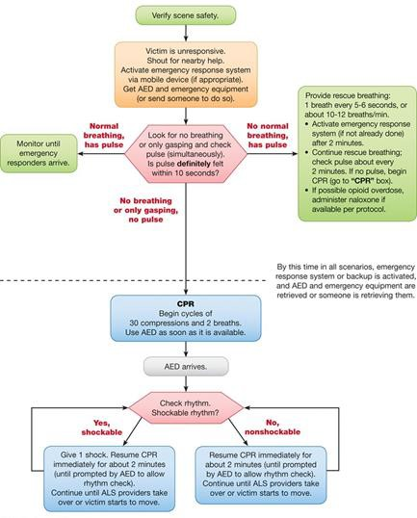

PEDIATRIC BASIC LIFE SUPPORT SINGLE RESCUER
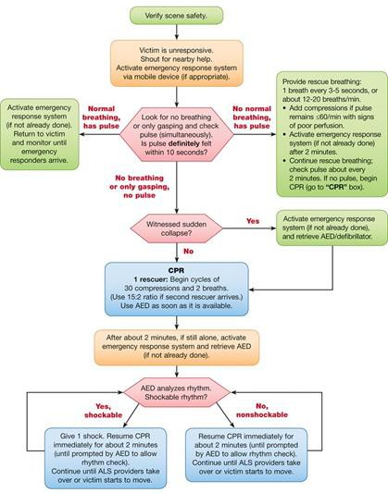

PEDIATRIC BASIC LIFE SUPPORT 2 OR MORE RESCUERS
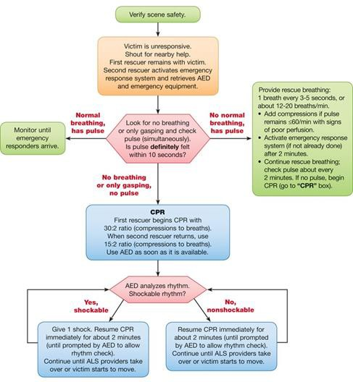

TAB 2 GUIDELINE 9
DEAD ON ARRIVAL (DOA) GUIDELINE

HISTORY  - Known medical conditions  - Last time known to be alive  - Patient encountered by EMS who meet criteria for obvious death  - Patient with DNR order in place who is  pulseless and apneic  - Patient for whom resuscitation efforts are  ceased on-scene | SIGNS / SYMPTOMS  - Apnic / pulseless  - Signs of decomposition  - Decapitated  - Burned beyond recognition  - Rigor mortis  - Dependent lividity | DIFFERENTIAL  - Death of apparent medical causes  - Suspicious death (law enforcement)

YES
Injury Incompatible with life? Decapitation, or
burned beyond recognition
LEGEND
EMR
EMT
A-EMT
EMT-P
MC Order

NO

YES
Signs of Decomposition, rigor mortis or extreme
dependent lividity?
NO

YES
Traumatic arrest and patient is in asystole on cardiac monitor

NO

YES
Reliable history indicates patient without vital signs for longer than 20 minutes without resuscitative measures and victim is cold?

NO

YES
Active DNR-CC, or CCA presented to the EMS
Providers?

NO

YES
Patient meets criteria for Termination of
Resuscitation?

NO

YES
Coordinate with Law Enforcement
Avoid disturbing scene or body
Law Enforcement and / or EMS Recognize Suspicious Death?

DO NOT Initiate resuscitative measures
Continue with Resuscitation Per Appropriate Guideline

NO
Coordinate with Law Enforcement and / or coroner.
Contacting Medical Control is not required.

TAB 2 GUIDELINE 10 TERMINATION OF RESUSCITATION (TOR)
- All decisions to withhold or terminate CPR and resuscitation efforts should be sufficiently documented and readily supported by this guideline.
- Criteria
  - For patient’s meeting Do Not Resuscitate criteria refer to DNR Guideline.
    - Whenever resuscitative measures are instituted, they must be continued until an appropriate DNR Form is verified.
  - For patient with obvious death refer to DOA guideline.
  - Blunt traumatic arrest – resuscitative measures can be terminated if ALS care available to perform cardiac monitor.
  - All EMS personnel involved in the patient’s care agree that discontinuation of the resuscitation is appropriate.

Requirements to be meet for termination of resuscitative efforts:
    - If a reliable history indicates that the patient has been without vital signs for longer than 20 minutes without any resuscitative measures being instituted.
    - Non-hypothermic.
      - Any victim, who appears dead but is hypothermic from environmental cold, should be provided with resuscitative measures immediately via the Cardiac Arrest – Hypothermic Guideline.
    - AED does not advise to “shock”.
      - ECG confirmation of death is not required for
        - Injuries incompatible with life.
        - Victim exhibits signs of decomposition, rigor mortis or extreme dependent lividity.
    - If resuscitative measures were initiated, then cardiac arrest guidelines have been followed for at least 20 minutes, including adequate CPR and advanced alternative airway with End-Tidal CO₂ (when available) levels < 10 mmHg after 20 minutes of resuscitation or a falling EtCO₂ sustained below 20 mmHg after 20 minutes of resuscitation.
    - Appropriate emotional support by family, neighbors, clergy or police is available at the scene if the family is present.

- For patients who have had CPR initiated prior to the squad arrival, and the EMT determines the patient meets the criteria set forth by the DOA Policy, CPR may be stopped.
  - If, while obtaining a reliable history, the patient indeed does meet the criteria for DOA, all life support measures may be stopped with permission from on-line MEDICAL CONTROL.
  - Avoid disturbing a potential crime scene unless it is necessary to do so to effect patient resuscitative efforts.
- If the EMT is unsure if the patient meets the exact criteria set forth by the DOA policy, then on- line MEDICAL CONTROL should be contacted and the case discussed. CPR should be continued during this time period.
- For patients who have had CPR initiated prior to the squad arrival and it is determined that the patient has a DNR Comfort Care or DNR Comfort Care / Comfort Care Arrest order in place, CPR will be discontinued.

In any case where doubt exists, clear documentation cannot be distinguished, or EMS feels that discontinuation of efforts at the scene would not be appropriate, the patient is to receive full resuscitative efforts and transported to the closest available hospital

TAB 2 GUIDELINE 11
DNR COMFORT CARE GUIDELINE
- The State of Ohio has enacted legislation (2133.21 to 2133.26) that provides guidelines to manage the class of patients designated as Do Not Resuscitate or DNR. Paramedics and EMT’s are protected under Ohio’s law from the following, resulting from withholding or withdrawal of CPR after a DNR Comfort Care is discovered, and after reasonable efforts have been made to determine that the DNR applies to their patient:
  - Criminal prosecution
  - Professional disciplinary action
  - Liability damages in a tort or other civil action
- There are two (2) official types of DNR orders:
  - DNR Comfort Care
    - DNR Comfort Care guidelines are activated immediately when DNR order is issued or when an appropriate living will specifies no CPR.
    - Comfort care means a dying person receives care that eases the pain and suffering during the final days or hours of life, but no resuscitative measures to sustain life will be implemented.
    - DNR Comfort Care does NOT mean, “Do Not Treat”.
    - For patients that have a valid DNR Comfort Care order:

YOU WILL | YOU WILL NOT
- Suction the airway  - Administer oxygen  - Place in position of comfort  - Splint or immobilize  - Control bleeding  - Provide pain medication  - Provide emotional support  - Contact other appropriate health care providers such as Hospice, Home health care, attending physician / Certified Nurse Practitioner (CNP) / Certified  Nurse Specialist (CNS) | - Administer chest compressions  - Insert an artificial airway  - Administer resuscitative drugs  - Defibrillate or cardiovert  - Provide respiratory assistance (other than that listed above)  - Initiate resuscitative IV (this does not include an IV for providing pain medications)  - Initiate cardiac monitoring

    - For those patients where any of the will not measures have been initiated prior to confirmation of the DNR Comfort Care status, discontinue these actions upon DNR Comfort Care confirmation.
  - DNR Comfort Care – Arrest
    - Unlike DNR Comfort Care, which is effective at the time the order is written, DNR Comfort Care – Arrest is activated only when a patient experiences a cardiac or respiratory arrest.
    - “Cardiac Arrest” means the absence of a palpable pulse and / or absence of spontaneous respirations and / or presence of agonal breathing.
    - DNR Comfort Care – Arrest allows for interventions to forestall cardiac and / or respiratory arrest. Interventions to forestall cardiac arrest include:
      - Insert oral / nasal airway
      - Administer resuscitative drugs
      - Initiate resuscitative IV
      - Initiate cardiac monitoring
- Identification of status
  - The following page shows the types of identification being used in Ohio for the DNR Comfort Care Policy.
  - EMS workers are not required to search a person to see if they have DNR identification. If an EMS or other health care worker discovers one of these items in the possession of the patient, the worker must make reasonable effort to establish identity of the patient, in appropriate circumstances. Examples of ways to verify identity include:
    - The patient, family member, caregiver or friend gives the patients name
    - The health care worker knows the patient personally
    - Institution identification band
    - Driver’s license, passport or other picture ID
- Interaction with patient, family and bystanders
  - The patient always may request resuscitation even if he or she is a DNR Comfort Care patient and this guideline has been activated. The request for resuscitation amounts to a revocation of the DNR Comfort Care status.
  - If family or bystanders request or demand resuscitation for a person for whom the DNR Comfort Care Guideline has been activated, DO NOT proceed with resuscitation. Provide

comfort measures as outlined above and try to help the family understand the dying process and the patient’s choice not to be resuscitated.
- Documentation
  - If the EMS provider implements the DNR Comfort Care Guideline, the following shall be documented
    - The item that identified the patient as DNR Comfort Care.
    - The method of verifying the patient’s identity, if any was found through reasonable efforts.
    - Whether the patient was a DNR Comfort Care or DNR Comfort Care – Arrest patient.
    - The actions taken to implement the DNR guideline.
- The DNR law does not govern all DNR orders; it applies only to DNR orders, which specific the Comfort Care Guideline. Physicians, CNS or CNP may write DNR orders which use a different guideline and which may better meet the patient’s needs.

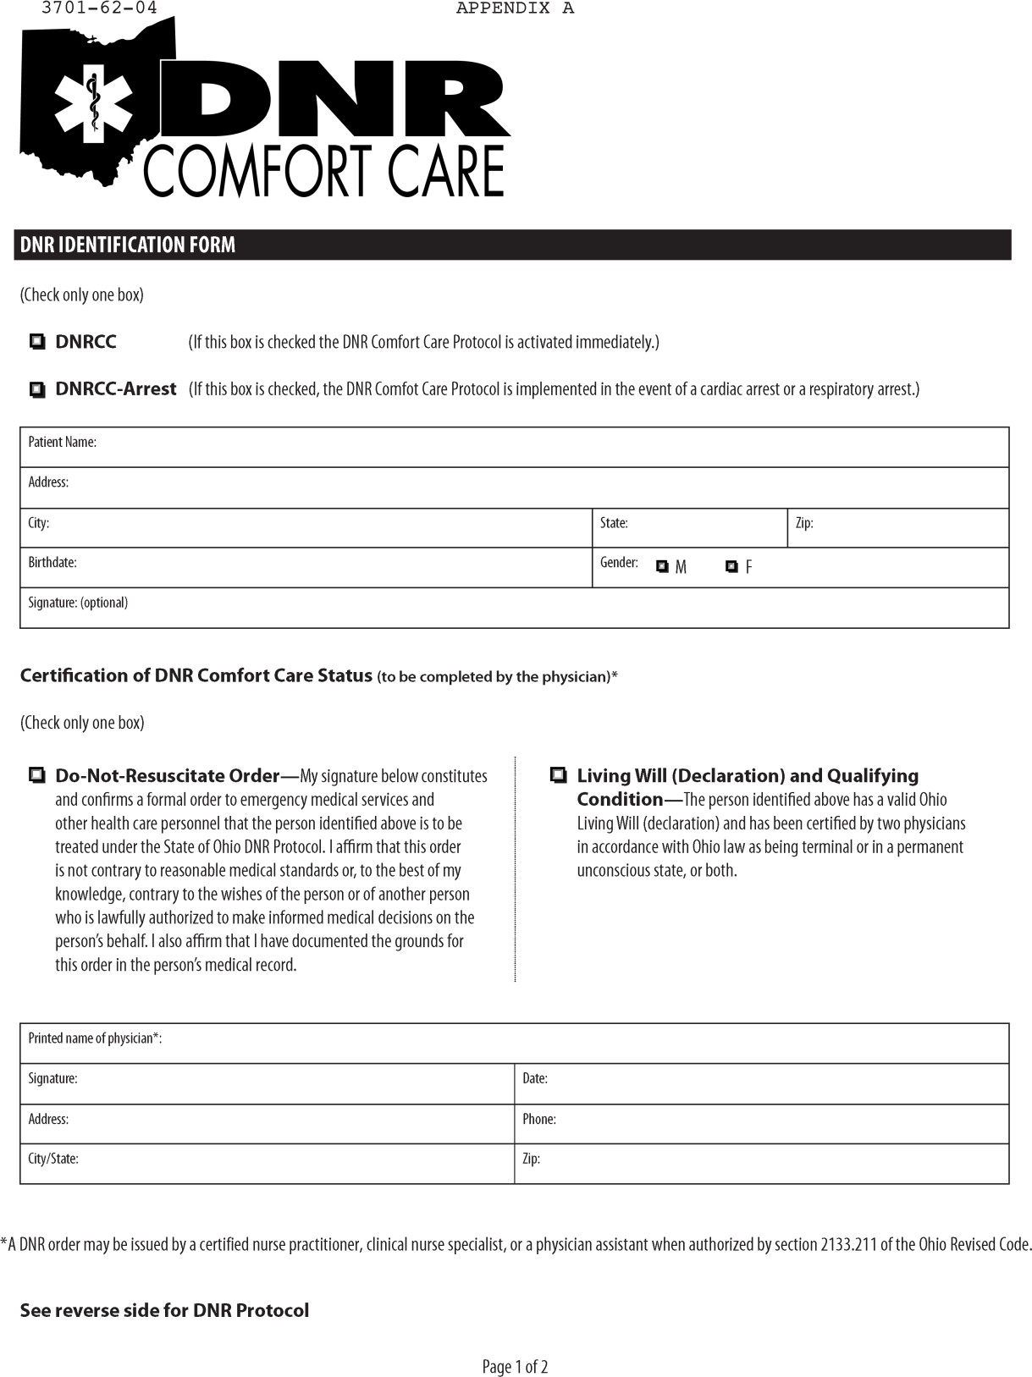

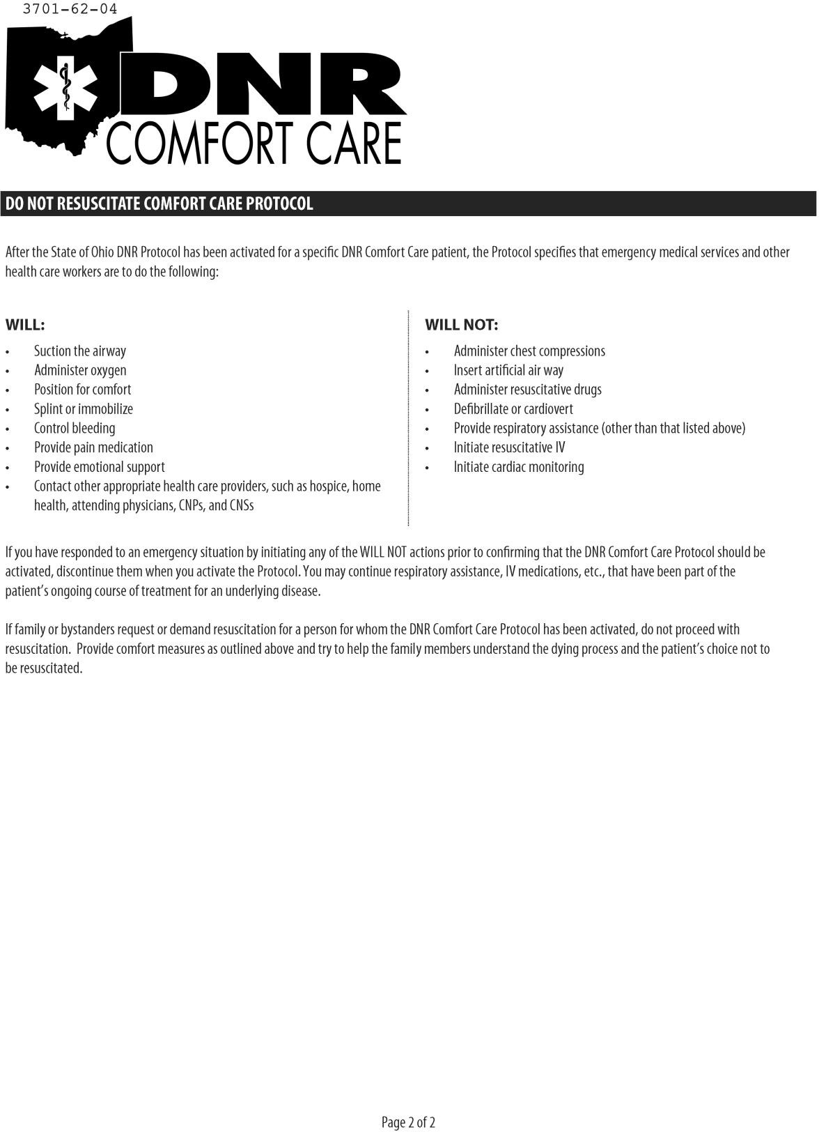

TAB 2 GUIDELINE 12
Consider CPR
if no pump sound, no pulse or blood pressure, and signs of hypoperfusion
LEFT VENTRICULAR ASSIST DEVICES (LVAD)

HISTORY  - End-Stage Heart Failure  - Patient has surgically-implanted pump that assists the action of one or both ventricles  - Patient may or may not be on a list for  cardiac transplantation | SIGNS / SYMPTOMS  - The flow through many of these devices is not pulsatile, therefore THE PATIENT MAY NOT HAVE A PULSE AT BASELINE. For this reason pulse oximetry readings may also be inaccurate  - Altered Mental Status may be the only  indicator of a problem  - Consider both VAD-related and non- VAD-related problems | DIFFERENTIAL  - Stroke  - Cardiac Arrest  - Dysrhythmia different from patient’s baseline  - Infection  - Bleeding  - Dehydration  - Cardiac Tamponade  - Device problem such as low battery or disconnected cable

YES NO
Signs or symptoms of possible device malfunction or failure
Problem with Circulation, Perfusion, SYMPTOMATIC Dysrhythmia not at patient’s baseline, any other problems
Universal Patient Care
LEGEND
EMR
EMT
A-EMT
EMT-P
MC Order

Determine type of device and asses any alarms
Call VAD Coordinator and
Discuss plan with Caregivers

YES
NO
Continuous Flow Device
If indicated, place defib pads away from LVAD site and ICD.
CALL VAD COORDINATOR and DISCUSS PLAN WITH CAREGIVERS
Treat per Appropriate Guideline
Pulsatile Flow Device
Auscultate chest for whirring mechanical pump sound. Assess patient for hypoperfusion: Altered Mental Status, pallor, diaphoresis
Measure pulse and blood pressure. If no pulse or blood pressure, providers should use the device’s HAND PUMP To maintain perfusion

Cardiac Monitor / 12-Lead ECG
Perform procedure if able to transmit, do not delay care to obtain EKG

Treat non-VAD related conditions per usual
Guidelines
Contact Medical Control
Transport to appropriate facility

ALWAYS talk to family / caregivers as they have specific knowledge and skills. CALL THE VAD COORDINATOR EARLY as per patient / family instructions or as listed on the device. They are available 24 / 7 and should be an integral part of the treatment plan
- There are a growing number of patients in the area who have a LVAD system. The LVAD system is continuously augments the left ventricle with pumping of blood
  - System Components:

- System Controller | - Emergency Power Pack (EPP)
- Power Base Unit (PBU) and cable | - System Monitor
- Batteries and battery clips | - Display Module

Precautions / Warning Specific to EMS Assessment and Treatment
  - LVAD patients will pose a challenge in the approach to assessment and treatment. ALS transport is strongly encouraged for an ill patient even with normal LVAD function.
  - Peripheral pulses may be absent with normal LVAD function and blood pressures may be unobtainable. Assessment must be based upon overall patient presentation including respiratory status, skin color and temperature, mentation and ECG findings.
    - Patient may have VF / VT and be asymptomatic
    - In the event of cardiac arrest, external chest compressions pose a risk to the location of the outflow graft on the aorta and the inflow conduit in the left ventricular apex.
    - Patients who present in cardiac arrest with a functioning LVAD unit should NOT
have CPR performed.
    - LVAD function can be assessed by placing a stethoscope over the device and listening for a whirling sound. All other standard therapies should be rendered as per guideline (i.e., airway control, defibrillation, medication administration).
  - The LVAD System Controller has a number of “advisory” and “hazard” alarms that may have to be addressed for optimal LVAD function. Rely on the patient or family member’s familiar with the device to troubleshoot the operation. Patients and family members have been educated in the function of the LVAD device.
- SPECIAL CONSIDERATIONS:
  - Batteries and the emergency power pack can provide 24 – 36 hours of power
  - Patients are frequently on three different anticoagulants and are prone to bleeding complications

Precautions / Warnings Specific to Patient or System Management

    - The LVAD should NOT be disconnected during external defibrillation or cardioversion
    - In the event that the LVAD stops operating, attempt to restore pump function immediately. In the event that the LVAD stops operating and blood is stagnant in the pump for more than a few minutes, there is a risk of stroke or thromboembolism should the device be restarted. There is also a risk for retrograde flow within the LVAD
    - Disconnecting both System Controller power leads at the same time will result in loss of pump function. One System Controller power lead must be connected to a power source (i.e., batteries, PBU, or EPP) at all times to maintain support
    - Avoid unnecessary pulling or moving of the external portion of the percutaneous lead, especially as the exit site is healing
    - The use of automated blood pressure monitoring devices may not yield accurate blood pressure data. Manual auscultation to assess blood pressure is recommended. In circumstances where the flow is not sufficient for auscultation, Doppler or invasive blood pressure monitoring may be required
- Utilizing the emergency contact information supplied, EMS Providers are encouraged to contact the LVAD specialists for questions related to LVAD function, power management, alarms, device management or patient assessment and treatment

